
A Winner Every Day!
A Drawing Every Day!
November 2025

Sun | Mon | Tues | Weds | Thurs | Fri | Sat
Thank you to all our prize donors.  Thank you to everyone who purchased a ticket. |  |  |  |  |  | 1  “Great Barrington Here & Gone”  from Gary Lavielle.  $ 25 Cash anon
2  Gift Certificate:  Hancock Shaker Village,  membership a $100 value | 3  $ 50 Cash  in memory of Barbara Allen | 4  Gift Certificate:  - Berkshire Theater Group  - two tickets  - a $120 Value | 5  Gift Certificate:  Berkshire Botanical Garden family membership  a $100 value | 6  Gift Certificate:  The Clark Art Institute  4 tickets  a $80 value | 7  Gift Certificate:  The Mount  4 tickets  a $88 value | 8  $ 50 Cash  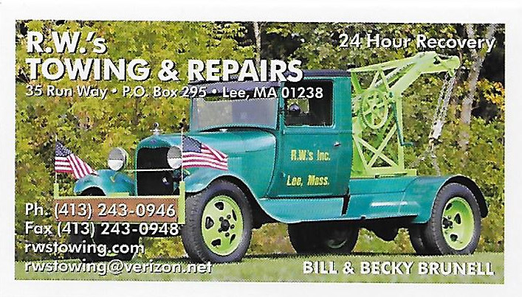  R W Inc
9  Gift Certificate:  Norman Rockwell Museum  2 adults  a $50 value | 10  Gift Certificate  :  - Terrace Hair Studio  an $ 100 Value | 11  $ 100 Cash  Comali Electric  Toole Ins.  two umbrellas | 12  $ 100 Cash  B Safe Storage | 13  :  - Locker Room  $ 25 cash cards (2) | 14  $ 50 Cash  In memory of Mary Morrissey | 15  Gift Certificate  Finders Keepers  a $50 value
16  $ 50 Cash  Gary O’Brien Property Services | 17  $ 75 Cash  Frank Consolati Insurance Porperty Services | 18  Gift Certificate:  Barrington Stage Company  a $140 value | 19  Gift Certificate  :  Shakespeare & Company  a $100 value | 20  Gift Certificate:  Mass MoCA  a $50 value | 21  $ 50 Cash  Gary O’Brien Property Services | 22  $ 100 Cash  Berkshire Liquors
23  $ 50 Cash  Lee Historical Society | 24  $ 50 Cash  R W Inc | 25  Gift Certificate:  Frasier Auto  Gift Card  Guido’s | 26  Gift Certificate:  Clark’s Nursery  a $100 value | 27  $ 50 Gift Cert  Henry’s Elec. | 28  $ 100 Cash  L B Corporation | 29  $ 100 Cash  Considine Leary & Arnold
Prizes may be added after tickets are printed. Ticket No
30
$ 200 Cash
October Mountain Financial
01Cash or Check Payable to:
LEE HISTORICAL SOCIETY PO Box 170 Lee, MA 01238
Please complete information below and return bottom portion to seller.
Keep the top portion for your records. Thanks for your support!
- - - - - - - - - - - separate here - - - - - - - - - - - - - -
Name: _______________________________________________________
Address: _____________________________________________________
E-mail: ______________________________________________________
Phone Number: __________________
Cost: $10.00

